APES
Ocean Acidification- FRQ

Name: _____________________________________________________________

Answer the following questions on the answer document- please make sure to LABEL each answer accordingly. Answer completely- DO NOT leave an answer blank. For the calculations- you MUST show your work and use UNITS.

Q: Coral reefs are produced when corals acquire calcium ions (Ca²+) and carbonate ions (CO₃²−) from seawater and deposit solid CaCO₃ to form their exoskeletons. Scientists are concerned that relatively rapid decreases in ocean water pH will hinder the deposition of CaCO₃. The graph above shows the amount of CO₂ dissolved in ocean water and ocean water pH (shown in parentheses) since 1850 and the predicted changes through 2100.

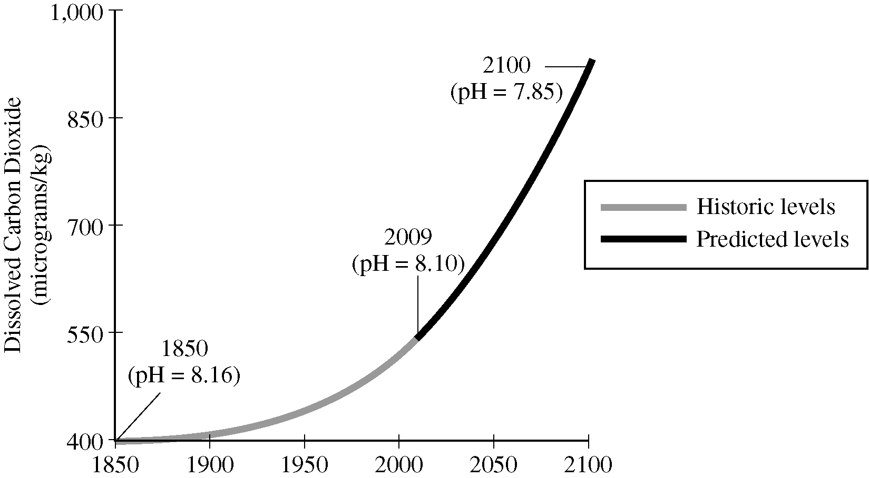

(a) Explain how an increase in the amount of dissolved CO₂ in ocean water results in a decrease in the pH of ocean water.

(b) Explain why the movement of carbon into the ocean has been increasing since 1850.

(c) In order to model the effects of ocean acidification on coral reefs, some simplifying assumptions can be made. Use the assumptions in the table below to perform the calculations that follow.
* Assume that the total global area of corals growing in reefs is 2.5 x 10¹¹ m².
Assume that corals grow only vertically and that the average vertical growth rate of corals is 3 mm/year.
* Assume that the average density of CaCO₃ in corals is 2 x 10³ kg/m³.

(i) Calculate the current annual global increase in volume, in m³, of CaCO₃ in coral reefs. Show all steps in your calculation.

(ii) Calculate the current annual global increase in mass, in kg, of CaCO₃ in coral reefs. Show all steps in your calculation.

(iii) Because of ocean acidification, it is expected that in 2050 the mass of CaCO₃ deposited annually in coral reefs will be 20 percent less than is deposited currently. Calculate how much less CaCO₃ , in kg, is expected to be deposited in 2050 than would be deposited if ocean water pH were to remain at its current value.

(d) Identify and describe one likely negative environmental impact of the loss of coral reefs.

(e) Identify one environmental problem (other than one due to ocean acidification or loss of coral reefs) that affects marine ecosystems on a global scale.

