APES- Chapter #6- Guided Reading
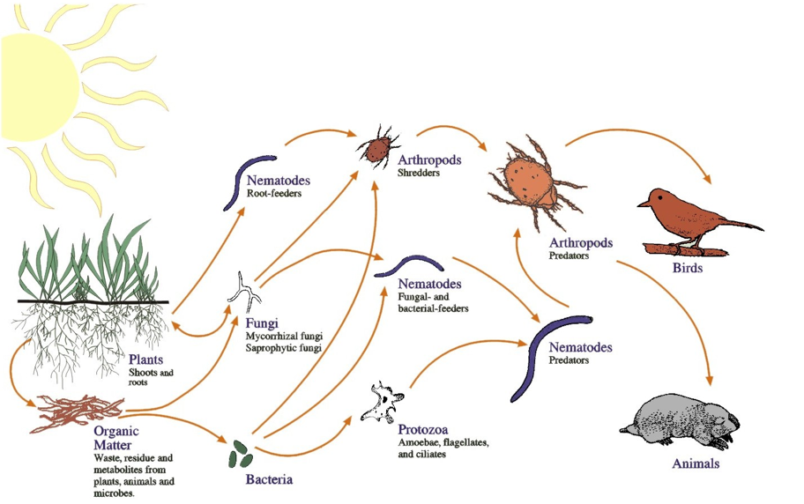
Ecosystems and Ecosystem Management

Name: ________________________________________

1: Create a food web diagramming The Acorn Connection (on a separate piece of paper)

2: What are the basic characteristics of ecosystems?

3: Create a trophic pyramid diagramming the Hot Spring Ecosystems in Yellowstone National Park (on a separate piece of paper)

4: Define community-level interactions and give an example.

5: In the Sea Otter example on pgs 104-105, What is the Keystone Species? Explain why.

6: Define and explain Watershed and give an example.

7: Read, “How Are the Borders of an Ecosystem Defined?” and answer the following questions:

- Given the intricate connections between the aquatic and terrestrial ecosystems along salmon streams, how would you define the boundaries of the ecosystem?

- When more adult salmon reach the spawning grounds than are needed to maintain the population, some are considered excess. How might the research described here affect that view?

- Some biologists have called salmon a keystone species. Given what you know about keystone species, how would you argue for or against this designation?

- In recent years, the numbers of anadromous fish along the Pacific Coast of North America have declined precipitously because of overfishing and habitat destruction. What effects would you predict this might have on the ecology of freshwater streams and their adjoining land areas?

- What types of management decisions about fish, wildlife, and forests would follow from recognizing the connection between aquatic and terrestrial ecosystems?

Study Questions:

- What is the difference between an ecosystem and an ecological community?

2: In what ways would an increase in the number of sea otters and a change in their geographic distribution benefit fisherman? In what ways would these changes be a problem for fisherman?

3: Based on the discussion in this chapter, would you expect a highly polluted ecosystem to have many species or few species?

4: Is our species a keystone species (humans)? Explain.

5: Which of the following are ecosystems? Which are ecological communities? Which are neither?

- Chicago
- A 1,000-ha farm in Illinois
- A sewage-treatment plant
- The Illinois River
- Lake Michigan

On your own: Do the “Eco-Test” for Chapter #6 in your Botkin- Student Review Guide

